**HOW TO BUILD OPENCV 3.3**

In this tutorial we’re going to learn how to build OpenCV 3.3 static libraries from source code and setup our visual studio 15 solution for run the below OpenCV hello world code.

<Paste here OpenCV hello world code>

1. **Download and install a C++ compiler installing the Visual C++ packages for visual studio 2015**
2. **Download the OpenCV 3.3 source code**

Download the OpenCV 3.3 source code from its [GitHub repository](https://github.com/opencv/opencv) using the download button or your favorite Git client

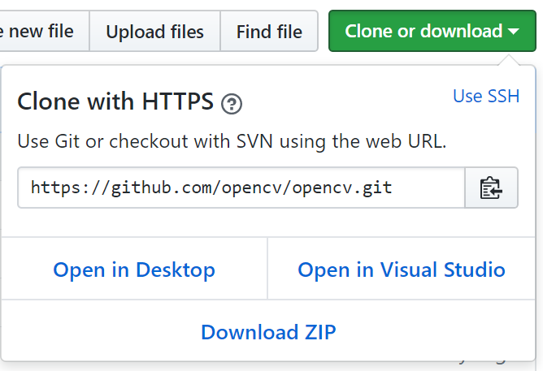

1. **Download and install Cmake**

Cmake is a neat tool that will let us create the visual studio projects files from “no-IDE” project files



1. **Download dependencies for build Highgui module**

In the above hello world code we can see an include for opencv2/highgui, this is an OpenCV module (as opencv2/core), if we want to use this fancy module for create windows, show images in windows and others useful GUI features we need to download and build the QT library from its [main page](https://www.qt.io/download-open-source/?hsCtaTracking=f977210e-de67-475f-a32b-65cec207fd03%7Cd62710cd-e1db-46aa-8d4d-2f1c1ffdacea) then click in **Qt Offline Instalers** > **Source packages & Other releases** > **For Windows users as a single**[**zip**](http://download.qt.io/official_releases/qt/5.9/5.9.1/single/qt-everywhere-opensource-src-5.9.1.zip)**file (698 MB)**



1. **Extract Highgui dependencies**

Extract QT source files projects for properly compile necessary dependencies for build OpenCV with Highgui module.

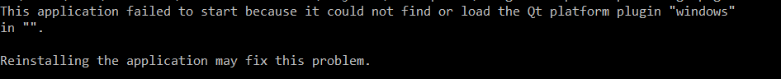

**DEPLOY A QT APPLICATION IN WINDOW**

[**https://stackoverflow.com/questions/21268558/application-failed-to-start-because-it-could-not-find-or-load-the-qt-platform-pl**](https://stackoverflow.com/questions/21268558/application-failed-to-start-because-it-could-not-find-or-load-the-qt-platform-pl)

[**http://www.tripleboot.org/?p=138**](http://www.tripleboot.org/?p=138)

[**http://wiki.qt.io/Deploy_an_Application_on_Windows**](http://wiki.qt.io/Deploy_an_Application_on_Windows)

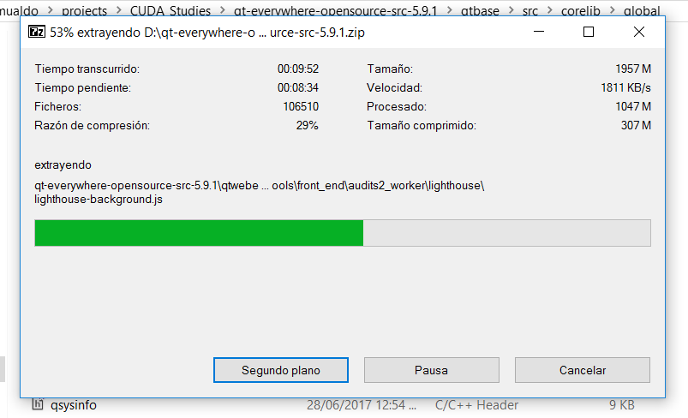

1. **Build necessary dependencies for OpenCV Highgui module from QT source files**

When you go to your extracted QT source files folder you’ll see a lot of folders with a **qt** prefix, those folders are called **QT** **modules** and you can find what the purpose of each module is by searching for [QT all modules](http://doc.qt.io/qt-5/qtmodules.html) in QT doc’s page.

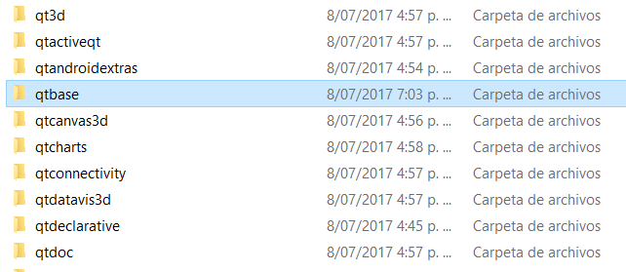

What is important to note here is that we won’t need all those QT modules for build our OpenCV highgui module, so we’ll skip most of those modules when building QT library